Advance Excel Assignment 1

1. What do you mean by cells in an excel sheet?
2. How can you restrict someone from copying a cell from your worksheet?
3. How to move or copy the worksheet into another workbook?
4. Which key is used as a shortcut for opening a new window document?
5. What are the things that we can notice after opening the Excel interface?
6. When to use a relative cell reference in excel?

xxxxxxxxxxxxxxxxxxxxxxxxxxxxxxxxxxxxxxxxxxxxxxxxxxxxxxxxxxxxxxxxxxxxxxxxxxxxxxxxxxxxxxxxxxxxxxxxx

1. What do you mean by cells in an excel sheet?

**Answer:** Cell is a rectangular box which occurs at the intersection of a vertical column and a horizontal row in excel worksheet.

Like columns A,B,C so on and Rows 1,2,3 so on. so each cell can be defined as a combination of column and rows like A2 , B3

1. How can you restrict someone from copying a cell from your worksheet? **Answer**: In order to protect your worksheet from getting copied, you need to go into Menu bar >Review > Protect sheet > Password. By entering password, you can secure your worksheet from getting copied by others.
2. How to move or copy the worksheet into another workbook?

**Answer:** Go to sheet, right click, then “Move or Copy”. Select desired sheet and TO

Book menu: click the workbook that you want to move the sheet to.

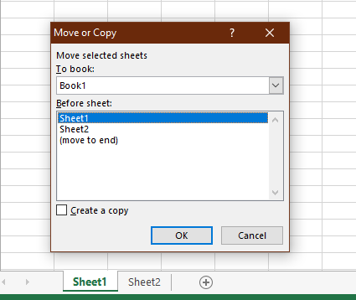

1. Which key is used as a shortcut for opening a new window document?

**Answer**: Ctrl + N will open new window

1. What are the things that we can notice after opening the Excel interface?

**Answer:** Interface components of Excel

* 1. Quick Access Toolbar
  2. Ribbon
  3. Name Box



* 1. Formula Quick Menu



* 1. Formula Bar



* 1. Status Bar - left bottom side
  2. Worksheet View options – right bottom side



* 1. Zoom Slider Control - right bottom side
  2. Zoom Percentage indicator - right bottom side



6. When to use a relative cell reference in excel?

Answer: Relative cell reference should be used whenever you need to repeat the same calculation across multiple rows or columns.